***Gitignore***

Create hidden file

nul > .gitignore

Now add all the files to git staging array:

**git add .**

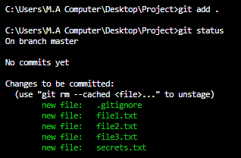

And check status.

Remove all the files from staging array and then add them in git setup.

**git rm --cached -r .** //. Means everything remove

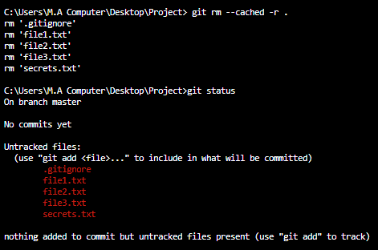

Now again add above files.

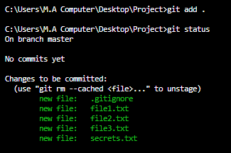

Inside **gitignore** file ignore files that you want first delete all files then ignore files you want inside **gitignore** file and again add and see that ignored files will not be added.

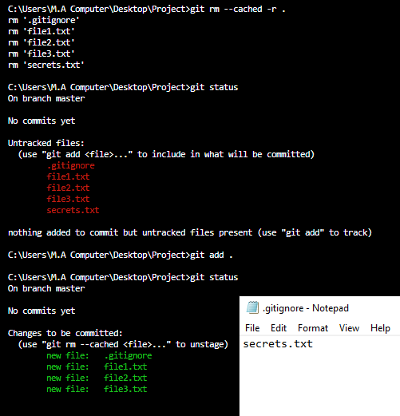

You can see that secrets.txt file that I ignored is not added.

Now add commit

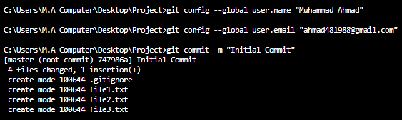

Now you can see that above four files are added and ignored is not added.

**Xcode project**